```

class Calculator{

int res;

void add(int a, int b)

{

res=a+b;

System.out.println(res);

}

}

public class Methods {

public static void main(String[] args) {

Calculator calc = new Calculator();

calc.add(10,20);

}

}

```

From the above program we can understood that if there is a need we can also write such a method which is accepting some parameters and not returning you anything.

When ever you have return in your method block, you should not have void in your method, for example ref below pro.,and based upon the return type (datatype) we have to write int or byte

```

class Calculator{

int a,b, res;

int add()

{

a=10;

b=20;

res=a+b;

return res;

}

}

public class Methods {

public static void main(String[] args) {

Calculator calc = new Calculator();

int c=calc.add();

System.out.println(c);

}

}

```

```

class Calculator{

int add(int a,int b) {

int res=a+b;

return res;

}

}

public class Methods {

public static void main(String[] args) {

Calculator calc= new Calculator();

int res=calc.add(20, 10);

System.out.println(res);

}

}

```

Snippet section:

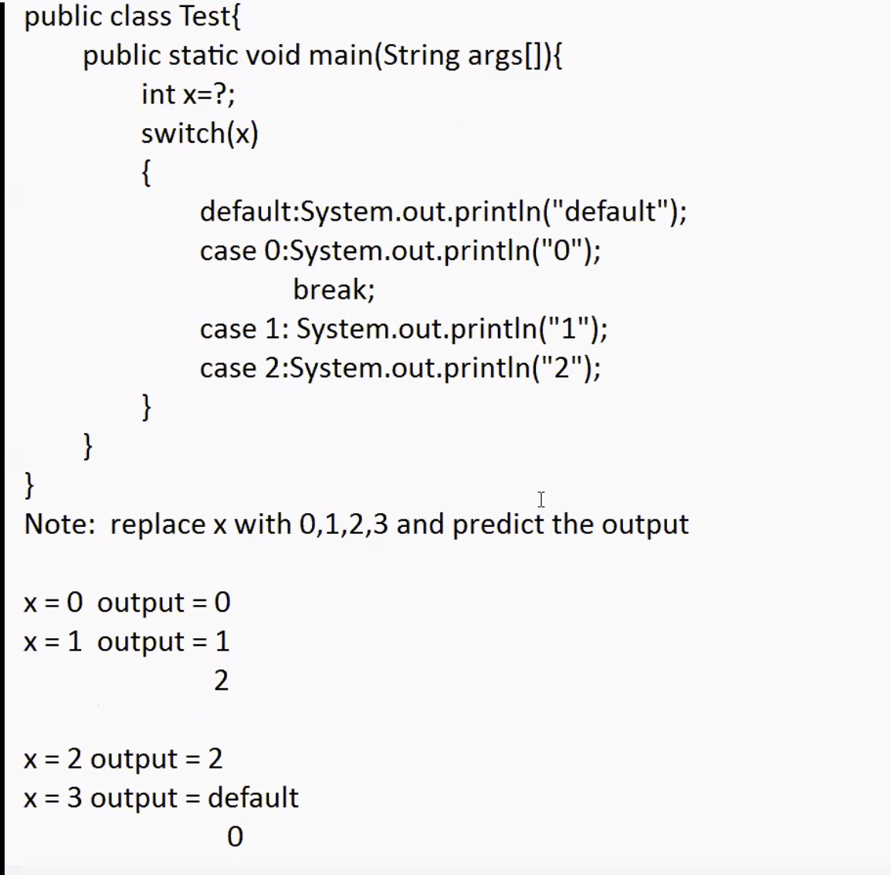

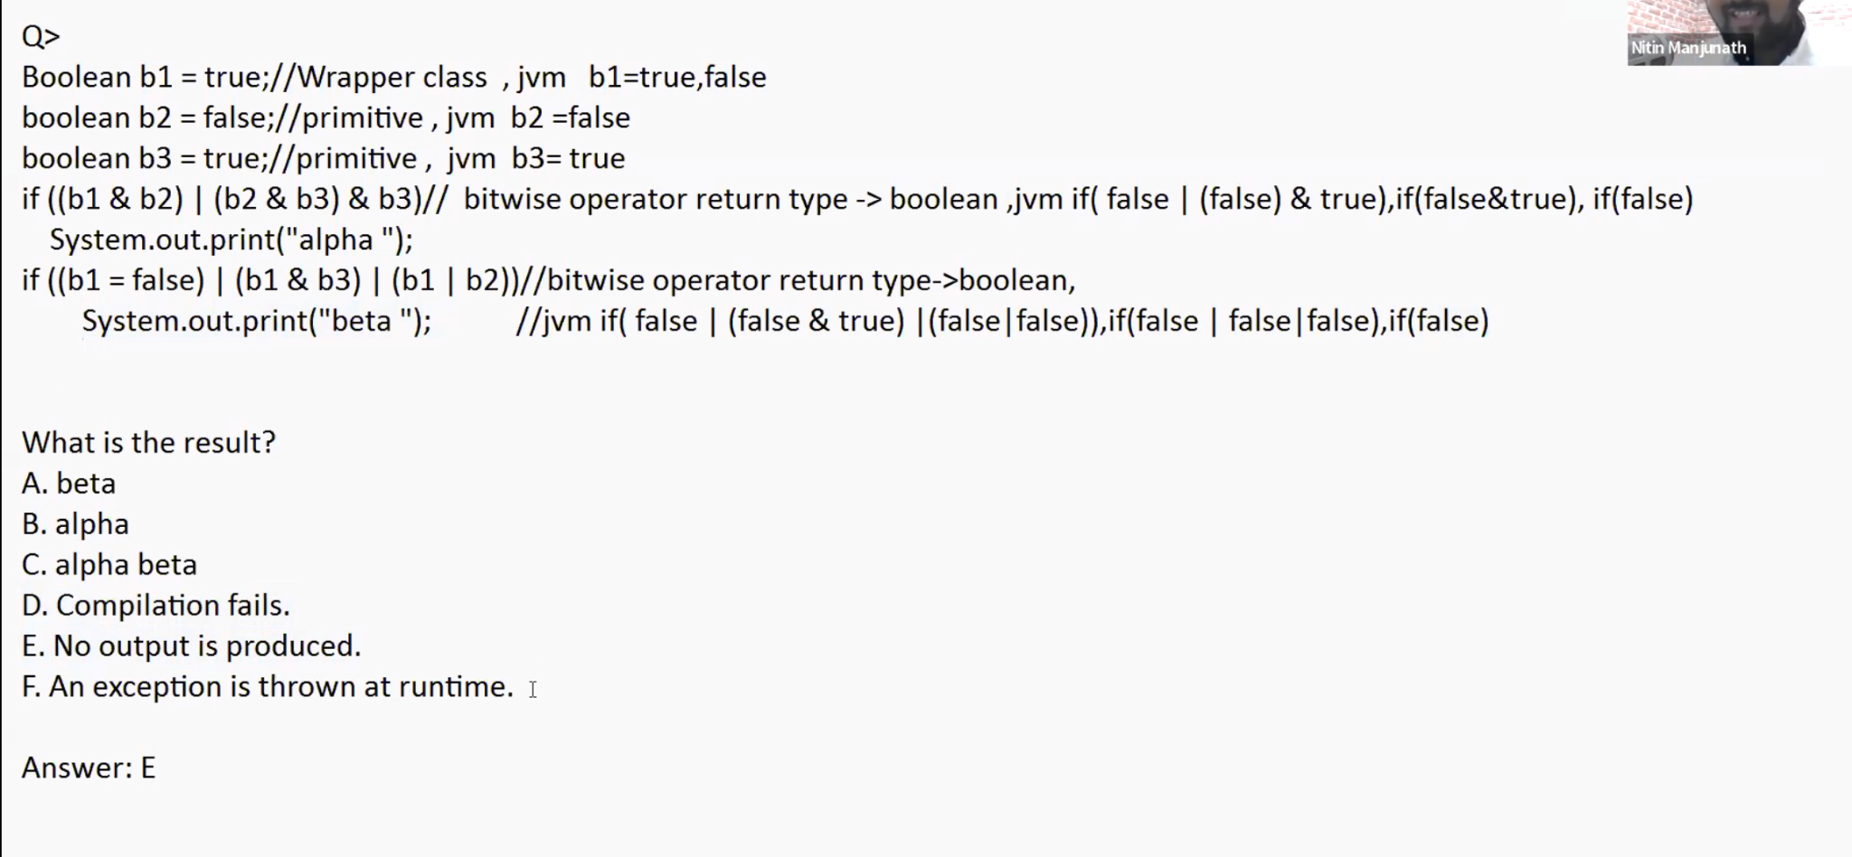

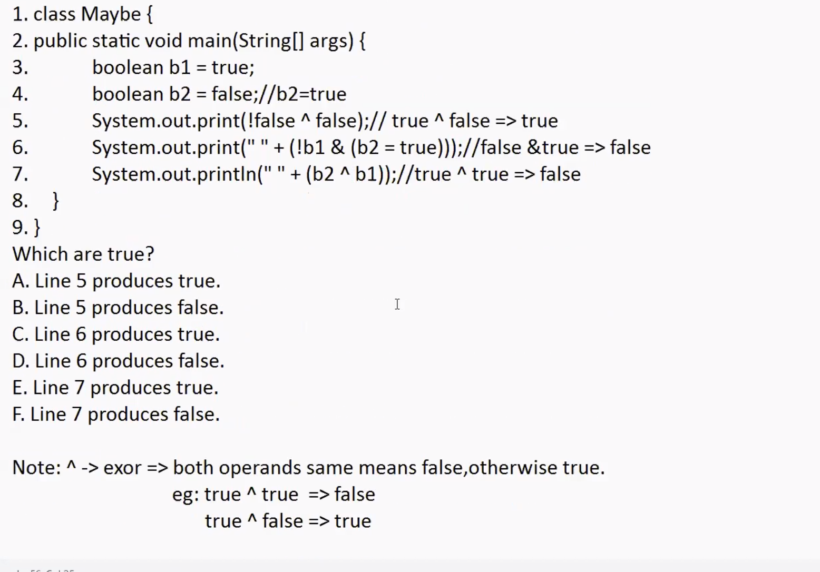

Above Question ans is ADF

